DoD Enterprise DevSecOps Reference Design from the DoD CIO – A Summary
Content referenced from: https://dodcio.defense.gov/Portals/0/Documents/DoD%20Enterprise%20DevSecOps%20Reference%20Design%20v1.0_Public%20Release.pdf?ver=2019-09-26-115824-583


DevSecOps – Defined by DoD CIO
DevSecOps is an organizational software engineering culture and practice that aims at unifying software development (Dev), security (Sec) and operations (Ops). The main characteristic of DevSecOps is to automate, monitor, and apply security at all phases of the software lifecycle: plan, develop, build, test, release, deliver, deploy, operate, and monitor. In DevSecOps, testing and security are shifted to the left through automated unit, functional, integration, and security testing - this is a key DevSecOps differentiator since security and functional capabilities are tested and built simultaneously.

Key Measures
Mean-time to production: the average time it takes from when new software features are required until they are running in production.
Average lead-time: how long it takes for a new requirement to be delivered and deployed.
Deployment speed: how fast a new version of the application can be deployed into the production environment.
Deployment frequency: how often a new release can be deployed into the production environment.
Production failure rate: how often software fails during production.
Mean-time to recovery: how long it takes applications in the production stage to recover from failure.

Key Principles to implementing a successful DevSecOps approach
- Remove bottlenecks (including human ones) and manual actions.
- Automate as much of the development and deployment activities as possible.
- Adopt common tools from planning and requirements through deployment and operations.
- Leverage agile software principles and favor small, incremental, frequent updates over larger, more sporadic releases.
- Apply the cross-functional skill sets of Development, Cybersecurity, and Operations throughout the software lifecycle, embracing a continuous monitoring approach in parallel instead of waiting to apply each skill set sequentially.
- Security risks of the underlying infrastructure must be measured and quantified, so that the total risks and impacts to software applications are understood.
- Deploy immutable infrastructure, such as containers. The concept of immutable infrastructure is an IT strategy in which deployed components are replaced in their entirety, rather than being updated in place. Deploying immutable infrastructure requires standardization and emulation of common infrastructure components to achieve consistent and predictable result

Conceptual Model

DevSecOps Lifecycle

DevSecOps Pillars

DevSecOps Ecosystem

DevSecOps Software Factory

DevSecOps MVP
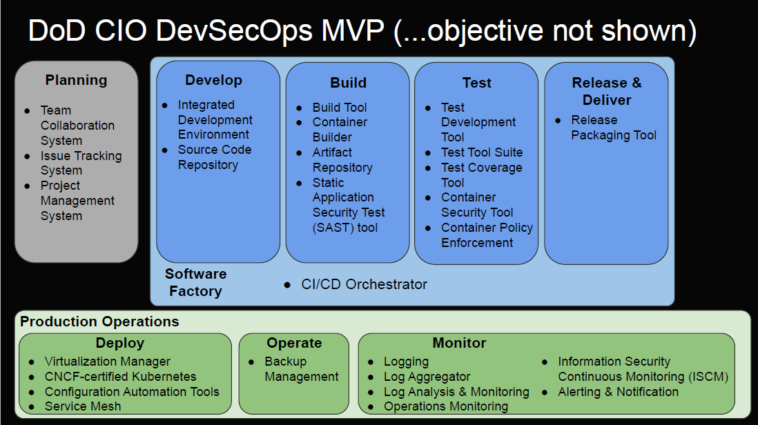
Image from https://github.com/jondavid-black/DevOpsForDefense/raw/master/Meetup/2019/2019-10%20DO4D%20-%20DevSecOps%20Reference%20Design.pdf

Containerized Software Factory Reference Design

Software Factory using Cloud DevSecOps Services

Sidecar Container Security Stack
Sidecar Container Security Stack enables: correlated and centralized logs, container security, east/west traffic management, a zero-trust model, a whitelist, Role-Based Access Control (RBAC), continuous monitoring, signature-based continuous scanning using Common Vulnerabilities and Exposures (CVEs), runtime behavior analysis, and container policy enforcement.

The security stack in the security sidecar container will include:
- A logging agent to push logs to a platform centralized logging service.
- Container policy enforcement. This includes ensuring container hardening from DCAR containers are preserved and complies with the NIST 800-190 requirements [12].
- Runtime Defense, this can perform both signature-based and behavior-based detection. This can also be used to send notifications when there is anomalous behavior.
- Vulnerability Management
- A service mesh proxy to connect to the service mesh
- Zero Trust down to the container level. Zero trust requires strict controls, never trust anything by default and always verify. Key aspects of zero trust at the container level include mutual Transport Layer Security authentication (mTLS), an encrypted communication tunnel between containers, strong identities per Pod using certificates, and whitelisting rather than blacklisting.
Services that support the security sidecar include:
- Program-specific Log Storage and Retrieval Service
- Service Mesh
- Program-specific artifact repository
- Runtime Behavior Analysis Artificial Intelligence (AI) service
- DCAR for the hardened containers
- Common Vulnerabilities and Exposures (CVE)Service / host-based security to provide CVEs for the security sidecar container

CSIAC Webinars - DoD Enterprise DevSecOps Initiative – Nicolas Chaillan presenting
https://www.csiac.org/podcast/dod-enterprise-devsecops-initiative/

DoD Centralized Container Source Code Repository (DCCSCR)
https://dcar.dsop.io/

DSOP Group Workspace
https://dccscr.dsop.io/dsop

DCCSCR Project Page
https://dccscr.dsop.io/dsop/dccscr

